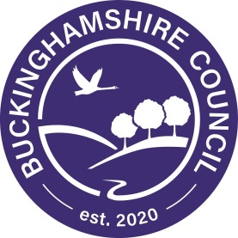

10 August 2020

Dear community leader,
Cases of COVID-19 are rising again across the country and we need your help to prevent an outbreak or local lockdown happening in Buckinghamshire.
We have prepared the following briefing about the importance of getting tested if you have any COVID-19 symptoms. We would really appreciate your help to spread this message with your communities. If you are a faith leader, please could you share this message with your community at services, prayers and events over the next few days.
If you could translate it into another language to tell people or share on social media like Facebook or in what’s app groups, that would be great too.
Thank you for your help. Let’s work together to stay safe and protect Bucks.
Book a test if you have any coronavirus symptoms
Cases of COVID-19 are rising again across the country. We do not want a local lockdown in Buckinghamshire. We want to stop the spread of the virus so that we can continue to live our lives and enjoy our freedom.
Follow our simple guidance:
- If you have any symptoms of COVID-19, even if they are very mild symptoms, book a test immediately and stay at home.

- Symptoms of COVID-19 are a high temperature, new continuous cough, loss or change in your sense of taste or smell.

- Stay at home if you have any symptoms of COVID-19 that started in the last 10 days, unless you have had a negative test result.

- Stay at home if you have been advised to self-isolate by NHS Test and Trace.

- Stay at home if someone in your household has had any symptoms of coronavirus and has not had a negative test result. If they have not done so, they should get a test.

There are testing centres locally, or you can order a home test. The test involves taking a swab of the inside of your nose and the back of your throat, using a cotton bud. You can do the swab yourself, or someone can do it for you.
We must protect our community from this deadly virus. Many people have already died, and it is our responsibility to stop the virus from spreading and taking more lives.
Help control the virus and protect yourself and others
- Wash hands – keep washing your hands regularly
- Cover face – wear a face covering over your nose and mouth to protect yourself and others
- Make space – stay two metres apart from other people not in your household wherever possible
Please, if you have any of the symptoms; a high temperature, a new continuous cough, or a loss or change in your sense of smell or taste, please book a test now. Call 119 or go online https://www.gov.uk/get-coronavirus-test

