Recovery Plan from impact of COVID-19

This plan was adopted by Full Council on 7 July 2020.

Stage 1 Crisis
The Government, Buckinghamshire and Hazlemere Parish Council are providing information to enable information to be disseminated locally.

Stage 2 Pre-Recovery Framework for Recovery
The Council need toy put in place plans and ideas ready for post-COVID-19, rather than thinking about them when we reach this stage. Innovation should be encouraged.

Stage 3 Recovery
This stage is about building capacity for recovery and transformation, working together on good ideas and plans and putting Stage 2 into action.

Stage 4 Recovery and Transformation
Establishing what the ‘new normal’ is going to be for Hazlemere and how the impact of COVID-19 has impacted and to continue to use creativity and ability to adapt as this might be needed to be continued in the future.

There will be many factors that are beyond Hazlemere Parish Council’s control. The new environment is going to look very different to what was known pre-COVID-19. Many of the changes to business practice may not revert to pre-COVID-19.

Stage 2 Pre-Recovery Framework for Recovery
BE READY AND UNITED FOR COMING OUT OF LOCKDOWN
Hazlemere Coronavirus Community Support Group has been set up involving the Parish Council and local volunteers. All meeting details are published, and anyone can attend any meeting (virtually or in person)?

Methodology
The following questions will need to be considered
1. Gain a realistic view of starting position / baseline. Where are we now?
2. Develop scenarios for different versions of the future. Where could we be?
3. Determine actions and strategic moves that are robust across the scenarios. What will we do?
4. Set trigger points that drive us to act at the right time. When should we start?
5. Be aware that this is likely to be a phased recovery. Consider each starting point e.g. set out below.

4 – 8 weeks | 2 – 6 months | 7 – 12 months | New normal?
Schools phased opening  Opening of play areas?  Opening of Public halls?  Lease holiday payments to continue?  Hazlemere Gardening  Association starting to  organise timed collections  out of their normal  opening hours  More grant application may be received? | Government funding continues?  Emergency food parcels for vulnerable and elderly will these continue?  Continued use of  Zoom for meetings?  Continue to work from home due to  shielding? | Loss of income for the hire of halls | ?

Ideas and information to include in the Draft Recovery Plan
- Hazlemere Parish Council would follow national public health guidelines and, where appropriate, national best practice. Lessons will also be learned from other countries/Parishes.
- Social distancing is likely to remain for some time.
- Create an Action Plan and review Funding Opportunities.
- Remember the target audience for any campaign including all age groups to include: social media, Parish Council noticeboards, shop window and Hazlemere Coronavirus Community Support Group.
- Consider a post Coronavirus event along the lines of Hazlemere Fete. Hazlemere Parish Council should acknowledge the huge debt we owe to all those people working on the front line during the crisis, often putting themselves at risk, and celebrate what they did and recognise their achievements. Celebrate the businesses and voluntary organisations which found new ways to make life more bearable for the community.
- Utilise all public open space
- Add a list of businesses that are trading now to social media and noticeboards.

Next Steps
Notes of Meeting and Draft Hazlemere Parish Council Recovery Plan need to be circulated.
Review responses and incorporate where appropriate.
Produce Action Plan with designated tasks to different organisations or groups of organisations, if appropriate.

To restart Hazlemere Parish Council life, we need to recognise some big changes which will have happened, whenever the lockdown ends:
• many older people, in forced isolation, will be in desperate need of contact
• there’s a much bigger network of community volunteers, and neighbourhood contacts
• many more people have learned how to work from home, and may want to avoid public transport

The aim is not to debate which scenarios are most likely but rather to explore what is possible, based on intelligence, where possible.
What impacts will we face e.g.
• Limited gatherings
• Travel restrictions
• Hygiene requirements
• Public confidence

TRANSFORMATION
The ‘new normal’ predicts a time when many places and destinations will be open, but the public will still need reassurance. Until a vaccine has been deployed throughout the population this ‘new normal’ will significantly impact on the use of public spaces.

At the same time, there will be an increased demand for public spaces and opportunities to meet, socialise and play. There may be less travel and a greater appreciation of local community, and this could put increased pressure on the Parish Council to make creative but safe use of places.

Conclusion
The lockdown has demonstrated what a social animal we are. To square the circle will demand a more omni-channel retail world with click and collect reducing the time in shops and local restaurants offering more home delivery. We cannot put the genie back in the bottle, so the opportunities for Hazlemere Parish Council to protect Hazlemere whilst making it inviting and, most importantly, safe.

Reviver Phase
Encourage public confidence in the context of post-COVID-19 restrictions.
Strategy Promote the Recovery Plan.
React quickly as a collaborative network.
Objectives Measure success against the other objectives agreed in the Recovery Plan.
Method Use the existing structure from Hazlemere Coronavirus Community Support Group to progress the Recovery Plan involving all interested stakeholders.
Gain a realistic starting position/baseline.
Develop plan of actions for the future.
Determine actions and strategic moves that are robust across the scenarios.

Specific Ideas for Hazlemere Parish Council
Report on how to come out Coronavirus Lockdown
CONSIDERATION:
Have staff been given written advice or referred to relevant documents re how they should work during the Coronavirus lockdown when I was on sick leave?
The Parish Council need to undertake a formal risk assessment of the office, halls, workplace and sites which should be published on the website.
Purchase/create formal signage in relation to safety measures for the Coronavirus.
Halls
An addendum re cleaning of the halls will be added to the booking form to ask users to clean before and after usage and to use the government advice for hand washing, 2m rules etc throughout the usage of the halls.
The keys will be cleaned after their return.
Staff will be provided with PPE of masks and gloves.
Sanitizers by entrances.

Staff Working Practices
Staff will be provided with PPE of masks and gloves.
2m rule and hand washing advice will be observed.
All office workstations are more than 2m apart, however the toilet and kitchen area will need to be cleaned everytime it is used.
The photocopier must be sterilised if different people are using it.
Consideration to be given to self-shielding Staff and Councillors.

Councillors
Consideration to be given to self-shielding Councillors.

Visitors to the Office and Site
The personal safety of the Member of the Public are their own responsibility, however they must observe the government advice when on Parish Council land and property.

Meeting Practices
Zoom meetings take away the need to meet
If these are not allowed and the 2m rule is needed to be observed the Parish Council may need to change the venue as the acoustics in Cedar Barn will not be good enough for a meeting.

Contractors
Their personal safety is their own responsibility, however they must observe the government advice when working for the Parish Council.

Outstanding Works from post Coronavirus list
To progress the tasks on the list as quickly as practical.

Hazlemere Gardening Association and deliveries and sales
Their personal safety and that of their customers and deliveries are their own responsibility, however they must observe the government advice when on Parish Council land and property. Risk assessment for collection of composts and products.

Allotments
The personal safety of the allotment holders are their own responsibility, however they must observe the government advice when on Parish Council land and property.

Play and Gym Areas: Currently these remain closed (Outdoor sports courts can be open but people must follow the government’s rules on social distancing)
The personal safety of the Member of the Public are their own responsibility, however they must observe the government advice when on Parish Council land and property.
Should the equipment be cleaned daily? Awaiting government advice when they are opened.
Would all Parish Council benches need to be taped to show the 2m rule?

Open Spaces/Woodland
The personal safety of the Member of the Public are their own responsibility, however they must observe the government advice when on Parish Council land and property.

It will be important to identify the key design issues and potential temporary interventions related to social distancing in green spaces. This will be particularly important where high levels of footfall are expected. The following steps could be applied:
1. Identify your public spaces these are more likely to be the three Recreation Grounds, woodland and open spaces. Typically characterised by high footfall.
2. Consider your user groups, levels of footfall and activity in spaces with intensive usage.
3. Assess the key social distancing issues, potential conflicts and risks. The likelihood of congestion could be at entrance and exit points, both to the green space and the play areas, particularly during warm dry weather and the lack of schools operating.
4. Consider the interventions that can be made to mitigate and reduce the social distancing issues, level of conflict, and risk.
5. Consider the statutory and legal implications and liaise with other statutory bodies, as appropriate.
6. Consider the implementation of temporary physical interventions, timings and procurement implications that will be suitable in the public realm. Including lack of ability to wash hands or hand sanitiation.
7. Consider the management of spaces and any necessary interventions.
8. Consider the maintenance issues such as cleaning and repairing.
9. Monitor use, management and maintenance, and effectiveness of measures.
10. Review and consider the phasing in and out of interventions.

Solutions
- One-way movement of pedestrians to maintain 2 metes (6 feet) distancing.
- Signing to encourage pedestrians to wait and allow others to pass at entry ways or along footpaths.
- Provide separate entry and exit routes for pedestrian access with clear signs e.g. Rose Avenue
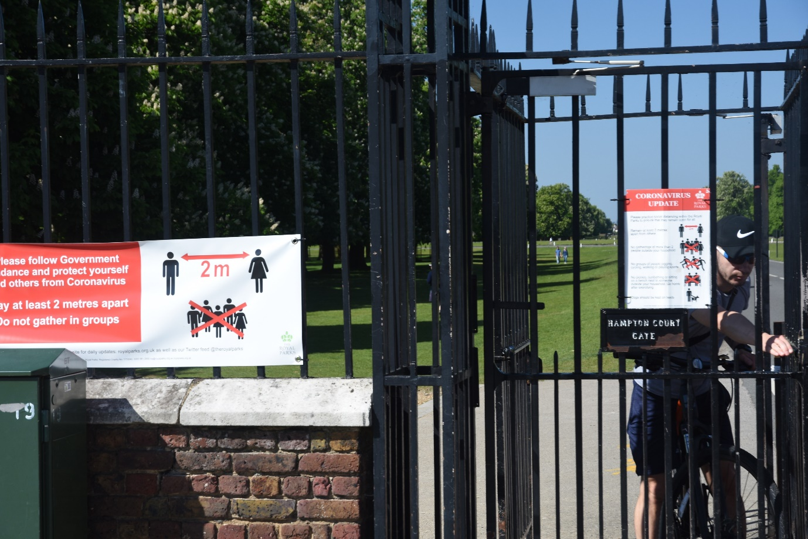

Ali Banham
Clerk
May 2020

